1. Frequency Error(Fail)
Condition | Mode | Frequency (MHz) | Antenna | Measured Frequency (MHz) | Frequency Error (Hz) | Deviation (ppm) | Limit (ppm) | Verdict
NVNT | a | 5260 | Ant1 | 5260.105 | 105000 | 19.96 | 20 | Pass
NVNT | a | 5280 | Ant1 | 5280.104 | 104000 | 19.7 | 20 | Pass
NVNT | a | 5320 | Ant1 | 5320.105 | 105000 | 19.74 | 20 | Pass
NVNT | n20 | 5260 | Ant1 | 5260.105 | 105000 | 19.96 | 20 | Pass
NVNT | n20 | 5280 | Ant1 | 5280.107 | 107000 | 20.27 | 20 | Fail
NVNT | n20 | 5320 | Ant1 | 5320.109 | 109000 | 20.49 | 20 | Fail
NVNT | ac20 | 5260 | Ant1 | 5260.112 | 112000 | 21.29 | 20 | Fail

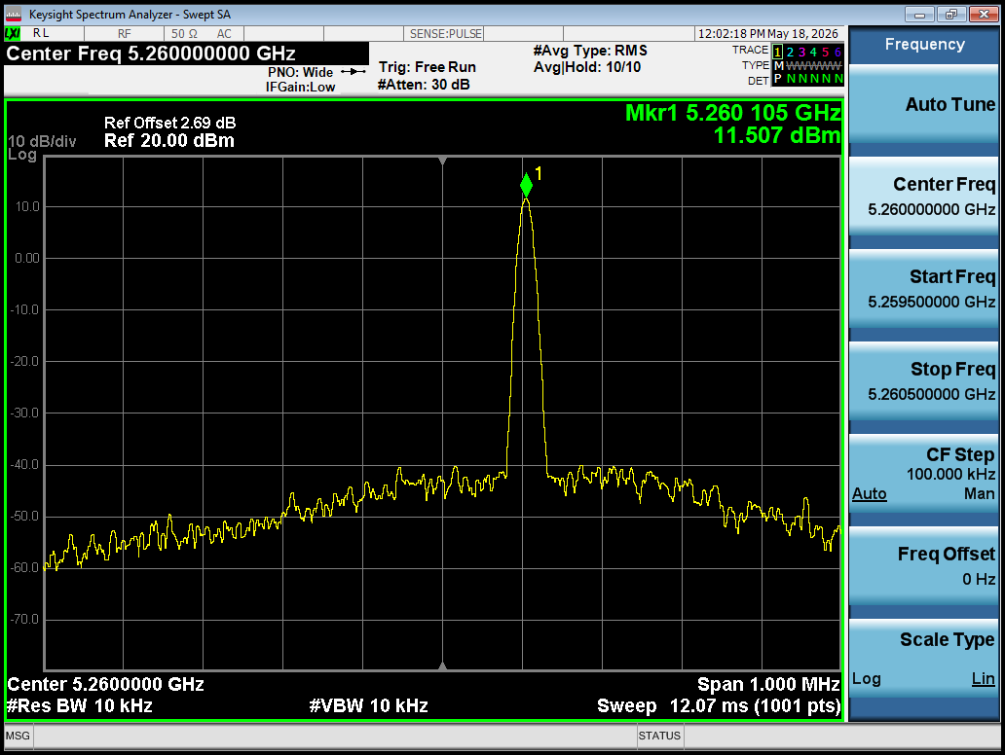
Freq. Error NVNT a 5260MHz Ant1
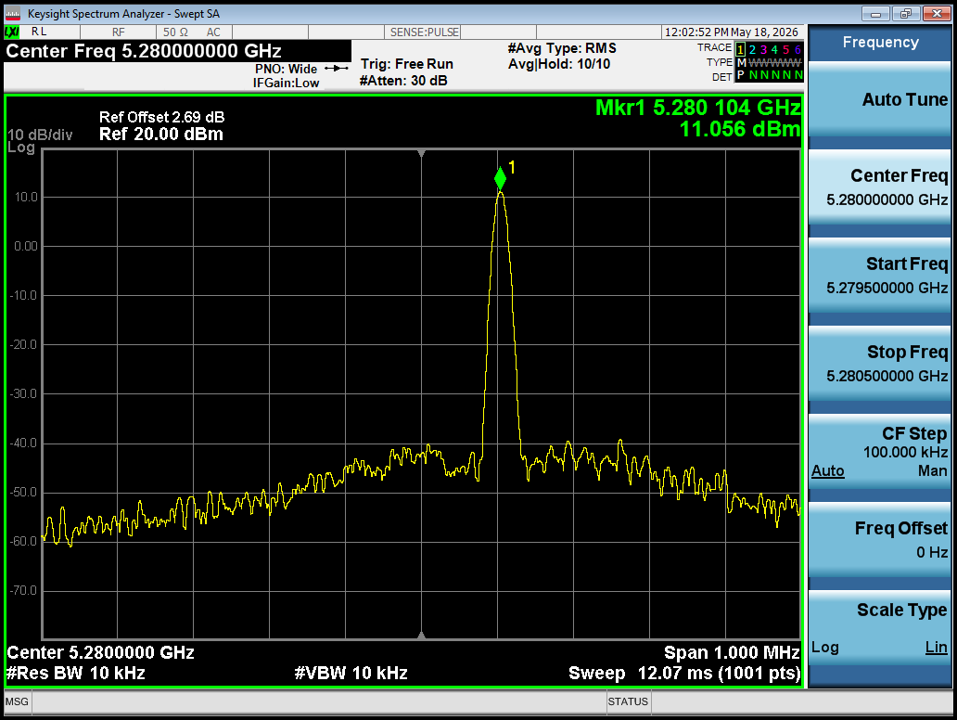
Freq. Error NVNT a 5280MHz Ant1
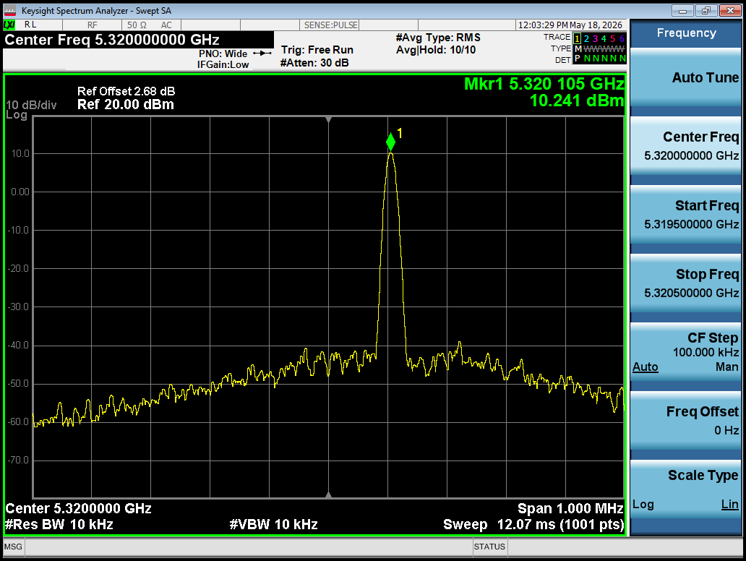
Freq. Error NVNT a 5320MHz Ant1
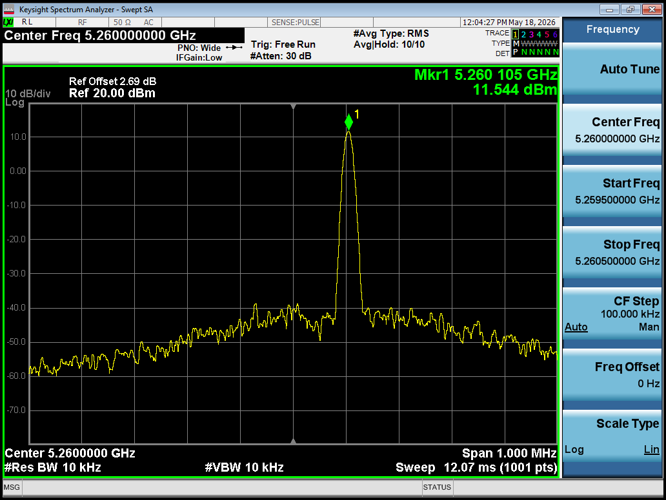
Freq. Error NVNT n20 5260MHz Ant1
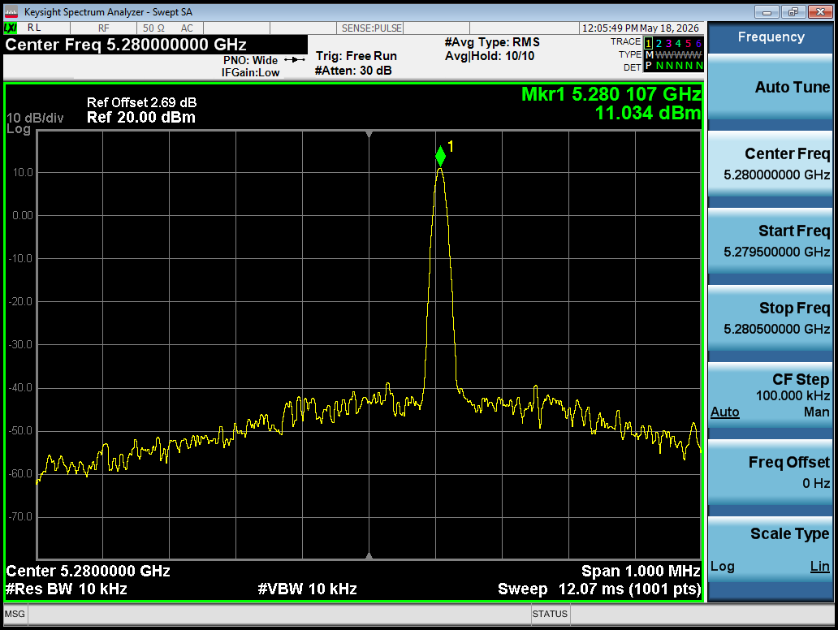
Freq. Error NVNT n20 5280MHz Ant1
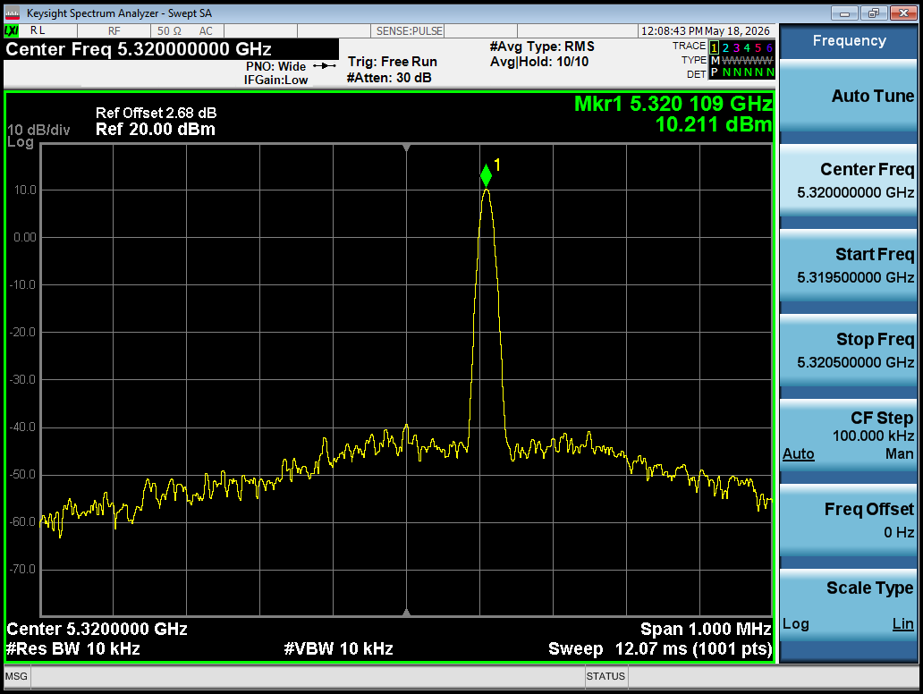
Freq. Error NVNT n20 5320MHz Ant1
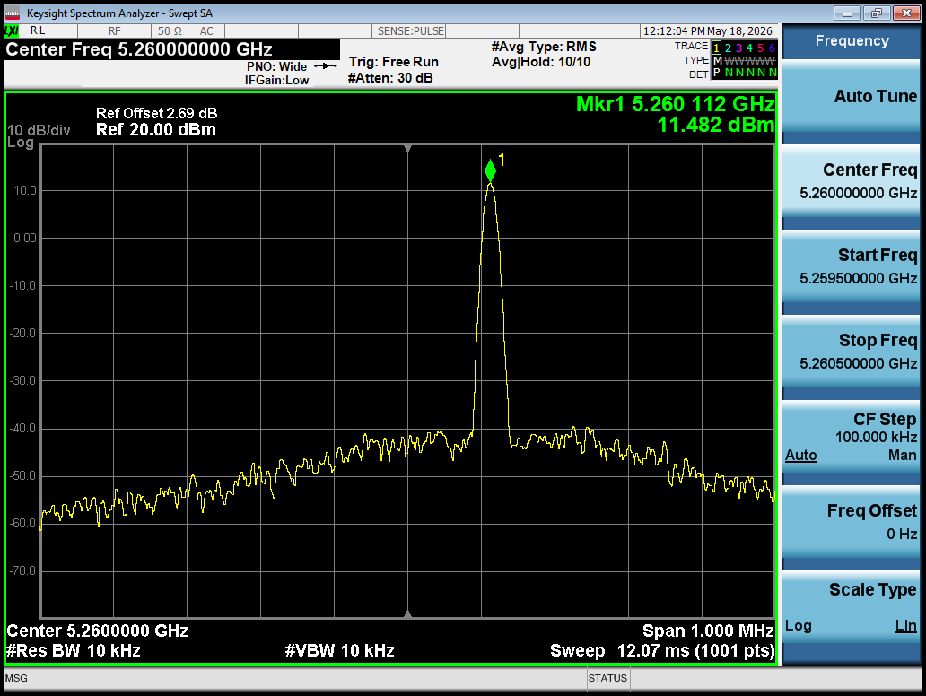
Freq. Error NVNT ac20 5260MHz Ant1

